Write Your Name in Cuneiform!
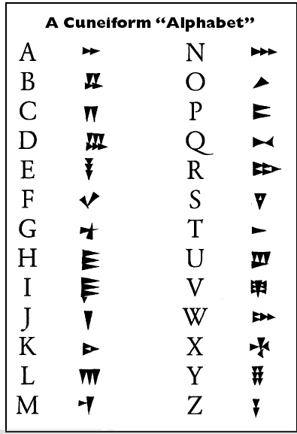Directions: Cuneiform is the world’s first system of writing. Looking at the chart below, you are going to write your first, middle and last name using cuneiform. You can then write your age in cuneiform as well. When you finish, you can create your clay tablet with your name with your playdoh. Make it colorful and creative!

My name is:

