Name:________________________________Date:____________________CP:_______C#:________

1. Identify ancient Egypt on the Map below.



__________________________________________

2. Identify Egypt on the map below.



_________________________________________________

3. What geographic landform was Lower Egypt located within?_______________________________

4. Which of the following **best** describes the **advantages** of trade? _____________________________

5. Like Mesopotamians, Egyptians were _____________________________________________

6. What was papyrus? _________________________________________________________

7. What written language is below? ________________________________________________

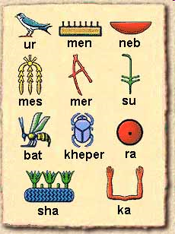

8. What was the most significant cultural event of the Old Kingdom in ancient Egypt?

_________________________________________________________________



9. Which of these events is the oldest on the timeline above? ____________________________________

10. What could this timeline be best used for? _______________________________________________

11. Which two factors **most** contributed to the expansion of Egyptian kingdoms? ___________________

12. This pyramid is an example of ______________________________________________

13. I was the first female to rule Egypt. I even wore the ceremonial beard to honor traditions. While I ruled I expanded trade throughout the region. Who was I? ________________________________

14. I was just a nine year old boy when I became Pharaoh of Egypt. I became famous when the modern world discovered my tomb. Who was I? _________________________________________

15. He was the first recognized ruler of both the Upper and Lower Kingdoms of Egypt. It is believed that he built the ancient city of Memphis and was the first to unify all of Egypt. Who was he?

______________________________________________________

16. I was one of the longest ruling pharaohs who protected Egypt from outside invasion. I was also the king in the Bible that refused to let the Hebrews leave with Moses. Who was I? _____________________

17. Today we call it Sudan. The ancient Egyptians called it _____________________________________

18. After breaking away from Egyptian rule, Kush eventually ___________________________________

19. As a result of being conquered by Egypt, Nubians _________________________________________

20. The upper class in ancient Egypt was made up of __________________________________________

21. The forced payments sent to the pharaoh by conquered peoples are called _______________________

22. Which best describes the type of government in Egypt after 3100 B.C.? ________________________

23. Who tried to give the Egyptians a new religion? ___________________________________________

24. The Egyptian invention to prevent the pharaoh’s body from decomposing was ___________________

25. The chief god of the Egyptians was __________________________________________________

26. The king who drove the Hyksos out of Egypt was _______________________________________

27. Why was Napata a favorable location for trade? _________________________________________

28. Kushite traders brought back cotton, textiles, and other goods in exchange for ___________________

29. How were the pyramids of the Kushites different from those of the Egyptians? __________________

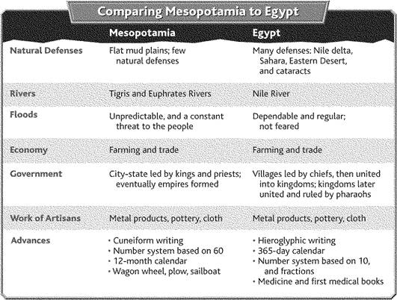

30. In what two ways are Mesopotamia and Egypt the same? ________________________________